**St. Paul**

**UNITED CHURCH OF CHRIST**

**July 20, 2025 10:30am**

Welcome! Whether you are a guest, friend or member, we are delighted that you are here. Large print bulletins are available at either door. Ask a greeter for any directions you may need.

*“Please note that this service will be live-streamed on Facebook. If you do not wish to be visible on camera, please let an usher know so we can take appropriate measures to ensure*

*your privacy."*

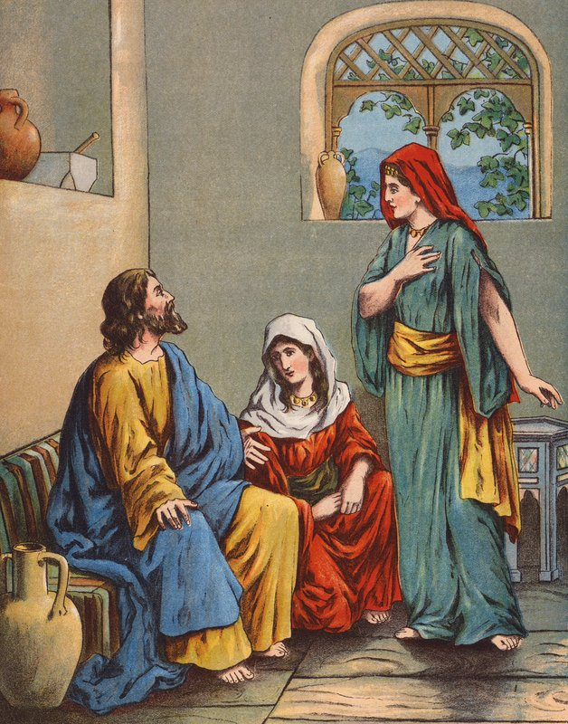

Rev. Jim Oleson, Pastor

Janet Morris, Musician

Joyce Noble, Liturgist

***Sixth Sunday after Pentecost***

*\*Please rise in body or spirit*

**Ringing of the Bell**

**Welcome & Announcements**

*In the last days, says God, I will pour out my Spirit upon all people. Your sons and daughters shall prophesy. Your young people shall see visions, and your old people shall dream dreams. People of God, we have been baptized into one Spirit and one body through Jesus Christ. Let us worship today.*

**Prelude and Lighting of the Candles**

**\*Call to Worship**

**Leader:** Christ is in our midst! How will you bid him welcome?

**People: We will throw open the doors to our hearts. We will delight in his presence.**

**Leader:** When God shows up, surprising things can happen.

**People: We will make ourselves ready. We will lay down our burdens and set aside our distractions.**

**Leader:** Here we receive good news: Nothing is too wonderful for God!

**People: So let us laugh and sing, rest and listen, dance and praise—**

**All: Let us worship God!**

**\*Invocation**

**Wonderful, surprising God, you bring us hope when we are discouraged, peace when we are anxious, and joy when we are least expecting it.**

**Help us, now, to rest in your presence.**

**Be our welcome Guest not only here but everywhere we go this week.**

**Show us how to receive all that you have to offer us.**

**May we remain open even to what seems too incredible to be true, for with you, so much more is possible than we even imagine.**

**We pray this in the name of your son, Jesus Christ. Amen.**

**\*Hymn of Praise** #459 New CenturyCome O Fount of Every Blessing

**Prayer for Transformation** **and New Life**   
**Gracious, inviting God, you continually provide us with opportunities to practice generous hospitality. But our fear of difference, reluctance to share, and desire to be in control make our welcome appear weak and insincere. Because we long for what is familiar and comfortable, we have difficulty honoring the stranger as a sacred guest who bears the face of Christ. Worn out and irritated by the work we think we must do, we miss opportunities to receive the gifts that such guests offer us. Forgive us, O God, for focusing on the wrong things. Show us how to do what is right. Amen.**  <pause for silent reflection >

**Words of Grace**   
My sisters and brothers in the family of God it is written for our benefit:

“Where sin abounds, grace abounds all the more.”

We can never outrun or out-sin God’s grace. Hear again Christ’s liberating word of grace:

“Your sins are forgiven.”

Thanks be to God!

**\*Response of Praise**

**Glory be to the Father, and to the Son, and to the Holy Ghost; As it was in the beginning, is now, and ever shall be, World without end. Amen. Amen.**

**Special Music** Bobby Roskowske

**Written Word**

Amos 8:1-12

Colossians 1:15-28

Luke 10:38-42

**Hymn** #503 New Century O Savior, Let Me Walk With You

**Message** The Big PictureRev. Jim Oleson

**Church in Prayer**

**Pastoral Prayer**

**Lord’s Prayer** (Debts, Debtors)

**Offertory**

**Invitation to Generosity**

**\*Doxology** (Tune: Old Hundredth)

**Praise God, from Whom all blessings flow; Praise Him, all creatures here below;**

**Praise Him above, ye heavenly host; Praise Father, Son, and Holy Ghost. Amen.**

**\*Prayer of Dedication**

**Generous God, we share what we have because we wish to serve you with the best we have to offer. Bless our tithes and offerings that they may become a bountiful feast for all who need to be filled with good things. Open our eyes to see the strangers you call us to welcome. Empower us to receive them as you do, with radically inclusive hospitality. May we recognize and delight in the gifts they share with us. Amen.**

**Closing Hymn** #495 New Century Called As Partners in Christ’s Service

\***Commission and Benediction**

**\*Christ’s Light Leads Us into the World**

**\*Congregational Response** #76 New Century Sent Forth by God’s Blessing

(Verse 1)

**\*Ringing of the Bell and Postlude**

903 Meier Road, Old Monroe, Missouri 63369

[stpauluccom@gmail.com](mailto:stpauluccom@gmail.com)

Website: stpauluccom.com

636-665-5329

**OFFICE HOURS**

Tuesday, Wednesday, Friday: 9:00am – 3:00pm

It Happens

Here St. Paul UCC

Weekly Calendar

July 20th - July 27th

**July 20th *Sixth Sunday after***

***Pentecost***

10:30am Worship

11:30am Fellowship Hour

July 21st

5:15pm Council Meeting

**July 27th *Seventh Sunday after***

***Pentecost***

10:30am Worship

11:30am Fellowship Hour

***Looking Ahead***

________________________________________________________________________________________

**OUR GIVING IN 2025**

**Needed weekly to meet our commitments** $**2317.02 $ 2317.02**

General Fund Offering July 13th  $1645.00 June Average $ 870.60 Stewardship Offering July 13th $ 0.00 May Average $ 1078.75 ______ ____________________________________________________ ____________________ ________

**HAPPENING IN OUR COMMUNITY**

**Sunday, August 10:** Immaculate Conception Old Monroe Parish Picnic. Serving from 11:00am to 6:00 pm all-you-can-eat dining, carry out from 11:45am to 7:30pm.

**Sunday, August 17:** Annual Picnic at Femme Osage UCC. Serving 11:30am – 6:00pm All-You-Can-Eat, cafeteria-style dining.

**Thank you to all our volunteers!**

**Greeters/Ushers**

Linda Meier & Marla Stewart

**Acolyte**

Marla Stewart

**Liturgist**

Joyce Noble

**Fellowship Hour**

Food Pantry



In our prayers …

This week we added prayers for Christian, and continued prayers for Lauretta.

We continue to keep in our prayers: Lauretta, Rich M., Steve, Mark H., Larry (Sharon’s grandson), Teresa, James T, Rick, Lynn and Ron D., Bill D., Cheryl V., Laurie S, Pat, Tosha D, Kenneth G., Kaelyn K., and the families of the victims of the flooding in Texas.

We lift up in our prayers those who need prayers for their *long-term circumstances*: Carol Jean P.

The Food Pantry needs the following items:

Toilet Paper, Shampoo/Conditioner, Soap, Soup,

PB/Jelly, Cereal, Canned Fruit.

**PLEASE, NO:** Mac & Cheese, Diced Tomatoes,

Corn or Green Beans!